***COMMUNITY BOARD EXECUTIVE COMMITTEE BEST PRACTICE AWARDS***

***2013***

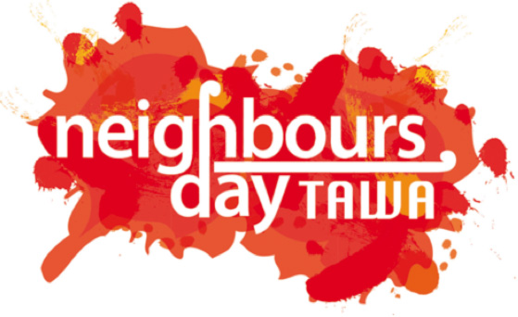

**Neighbours’ Weekend in Tawa – March 2012**

Instigated by the Tawa Community Board under the Wellington City Council

Contact: Malcolm Sparrow (Tawa Community Board chair)

9 Brasenose Place

Tawa

Wellington 5028

(04) 232 5030 [malcolm@tawalink.com](mailto:malcolm@tawalink.com)

Category – **Enhancing Communities**

Neighbours’ Weekend in Tawa was initiated with a view to encouraging people in Tawa to get

together with their neighbours over a barbecue or similar in connection with Neighbours’ Day

Aotearoa, to get to know people in their own streets better, to make newcomers welcome, and

as a result contribute to making their neighbourhoods better places in which to live.

It’s all about “building a community before you need one”.

27 February 2013

**NEIGHBOURS’ WEEKEND IN TAWA – MARCH 2012**

**THE INITIAL PLANNING IN 2011**

In August 2011 a small group of locals got together to discuss Neighbourhood Support in Tawa.

It comprised:

- two Tawa Community Board members (the chair and a Wellington City councillor)

- the Tawa community constable

- a Neighbourhood Support representative from the Wellington City Council

- the Tawa Neighbourhood Support coordinator

- a Tawa Lions’ Club representative

At that initial meeting the idea was mooted of “getting on board” Neighbours’ Day Aotearoa and actively encouraging as many streets as possible in our suburb to arrange some sort of get-together on the weekend of 24-25 March 2012. We set for ourselves a target of seeing 50 neighbourhood get-togethers take place that weekend.

Our small group continued to meet every few weeks to plan towards the occasion. When we became aware of Wellington City Council offering grants for “Emergency Preparedness”, the Tawa Progressive & Ratepayers’ Association kindly applied on our behalf for funding, primarily to cover the costs of promoting the event Tawa-wide – to all 14,900 residents. We were advised in December that we would be receiving a grant of $2500.

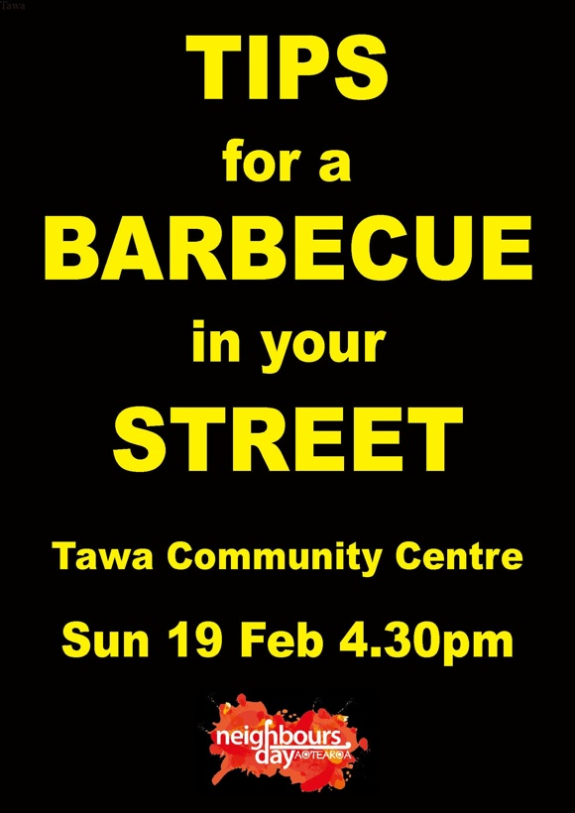**FIVE WEEKS BEFORE THE EVENT**

The project continued to be driven mostly by chair Malcolm Sparrow and Cr Ngaire Best from the Tawa Community Board with the support of the rest of the board.

In mid-February 2012 we invited community representatives and other members of the public to a meeting where we would provide “Tips for a Barbecue in your Street”. Around 55 people were present and they were encouraged to go out and make contact with others in their own street to hold a neighbourhood barbecue, afternoon tea, pot luck meal (or whatever) on, or close, to Neighbours’ Day in later March.

Along with the two presenters from the Tawa Community Board, two other Tawa individuals shared something of their previous experience in running neighbourhood get-togethers. And the local Neighbourhood Support coordinator spoke of his hope that further Neighbourhood Support groups might develop from these small beginnings.

The concept of “building a community before you need one” was pushed very strongly. We were intrigued by the number of people who liked the idea of sharing a barbecue with their neighbours, people who had previously thought about organising something but hadn’t got around to it, who now indicated they would be using Neighbours’ Weekend in Tawa as a catalyst to actually ensure it happened in their street. We promoted the idea of starting out very simply with a low-key gathering of a handful of neighbours to meet and eat together. Those who wished to take it to the next level and compile a list of people in their street along with comprehensive contact details were also encouraged to do so, but that wasn’t necessarily the object of the exercise at the outset.

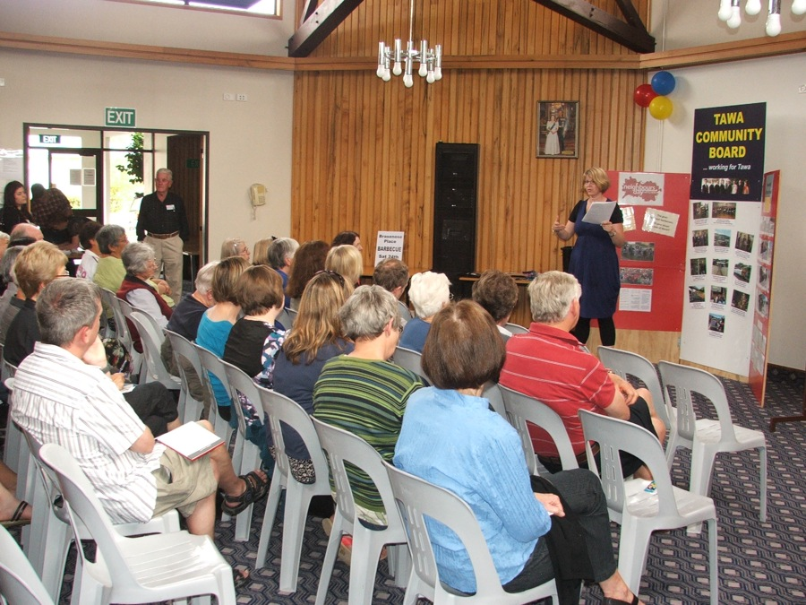

**THE WEEKS LEADING UP TO NEIGHBOURS’ WEEKEND IN TAWA**

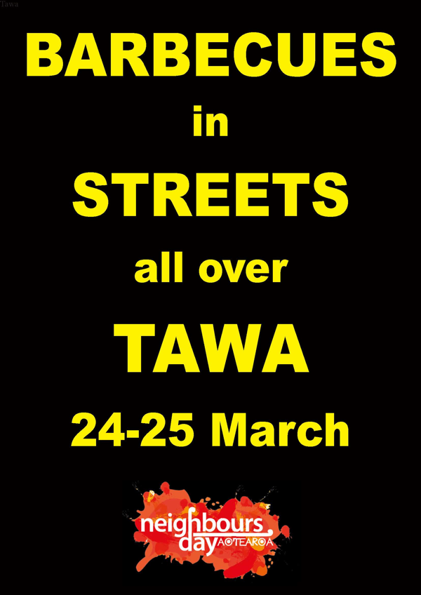We encouraged people to register with us the proposed get-together in their particular street. This would enable us to keep a tally of when and where various events were happening, and also to provide a small number of resources.

The event was promoted in or on:

* Tawa’s community eNewsletter which goes to

around 1200 out of 4600 local residences

* tawalink.com, the local community website
* school newsletters
* church newsletters
* local newspapers
* posters in shop windows
* billboards at both ends of Tawa’s Main Road

In addition to that, Lions’ Club members put up 15 or so small corflute signs throughout the community.

We printed 5000 circulars using the Neighbours’ Day Aotearoa emergency preparedness leaflet, and adapted it to suit Neighbours’ Weekend in Tawa. In early March we engaged a group of students from Tawa College to distribute these to every household in the community. The cost of that exercise consumed about 50% of the grant we had received, but we considered that continuing to emphasise the importance of community preparedness was worth the expense.

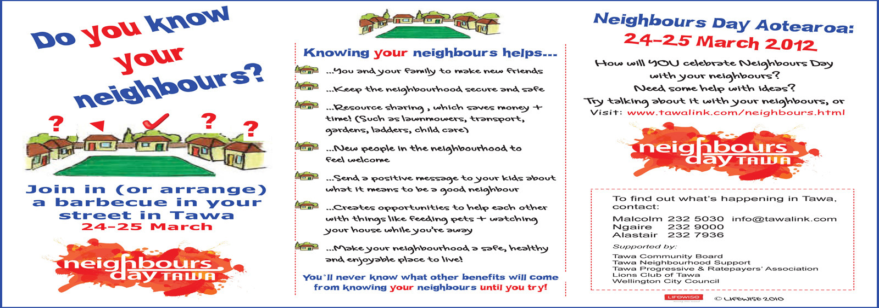

*One side of the leaflet that was distributed to every household in the community*

Meanwhile registration forms were starting to come in from various street organisers confirming involvement in the event. We secured three “BBQ packs” from the Tawa New World supermarket to be used as prizes for streets that had registered by a certain date. The names of three streets were drawn out of a hat as winners of the packs which included sausages, bread, tomato sauce and soft drinks. See the photo.

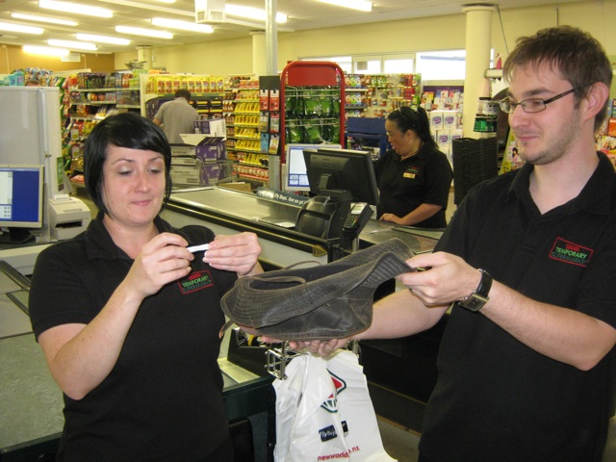The Emergency Preparedness team at the Wellington City Council made kits (light blue bags) available to us for distribution to each street organising a Neighbours’ Day activity. These included various papers and checklists, along with assorted goodies from various sponsors, such as a packet of teabags, some small chocolate bars, free coffee coupon, etc. The Tawa Neighbours’ Weekend team added a supply of balloons and nametags, along with a personalised corflute sign promoting the barbecue in each street.

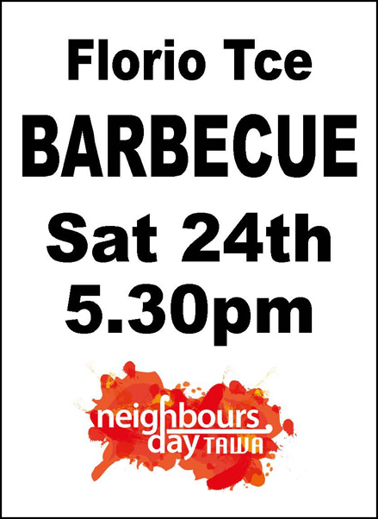

Most streets taking part in Neighbours’ Weekend in Tawa used the corflute sign that we supplied to them to advertise the get-together in their street. It served a twofold purpose:

* to remind locals of the upcoming event
* to let other community members know that barbecues were happening all over Tawa

With some 50 signs displayed around the community – on posts, poles, fences, etc – we considered that most people would have had some idea that something special was happening.

A host of tips was made available on our own website, as well as templates for street invitations.

We continued to liaise, by email and phone, with every contact on our list.

Whilst most groups indicated they would be getting together on Neighbours’ Weekend itself, a small number decided it suited them better to meet the previous or the following weekend. In the end, the fact that they were getting together with their neighbours was the only thing that really mattered.

As the time approached, we were helped with a limited amount of publicity in local newspapers and on the Wellington City Council website, including this report three days beforehand:

*“Tawa will be hosting at least 36 street barbecues this weekend to celebrate Neighbours’ Day Aotearoa - the national initiative to get as many people as possible to get to know their neighbours.*

*There are more than 50 private celebrations about to take place in streets, suburbs or apartment buildings around the city …..*

*“I’m thrilled so many Wellingtonians are taking part, and hats-off to Tawa in particular. Their enthusiasm is really impressive,” says Mayor Celia Wade-Brown.”*

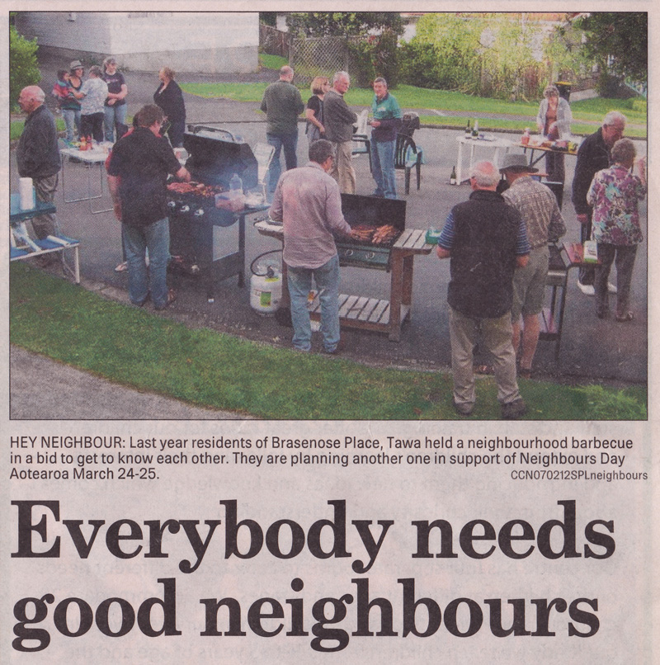

*Porirua CityLife News*

**NEIGHBOURS’ WEEKEND ITSELF**

As it turned out, a total of 51 gatherings were held in Tawa neighbourhoods on Neighbours’ Weekend or on a close weekend. Most were barbecues but some were afternoon teas or drinks and nibbles. Some were at the end of a cul-de-sac, others on a grass verge or in someone’s backyard. Some were in a lounge, others in a double garage. Some involved as few as four households, others saw more than 40 people participate. One or two took the initiative and involved the Tawa Volunteer Fire Brigade and the Tawa Community Patrol.

All up, 1100-1200 people throughout Tawa took part in Neighbours’ Weekend get-togethers, many meeting others from their neighbourhood for the first time. Most members of the Tawa Community Board organised a barbecue in their own streets.

The feedback was incredibly positive. We encouraged each street to submit a brief report on how things went at their get-together, and to provide a photo or two. Every street obliged, and about half submitted one or more photos.

These were all added to our website at <http://www.tawalink.com/neighbours_street_list.html>.

Here are comments received from many of the neighbourhoods involved:

*“The weather was great and the food & company fantastic! It was a good excuse to catch up with existing neighbours and to meet the new families who have recently made our street their home. Everyone agreed it was a great idea and we loved every minute!”*

*“In our four houses we have an American, South African, Kiwis, Vietnamese, and Indonesians. I’m sure we’ll get together again at some stage.”*

*“We met people we hadn’t before and everyone chatted away and mingled well. Kids now know more kids to play with.”*

*“Everyone had a great time and it is certainly something that we would like to repeat.”*

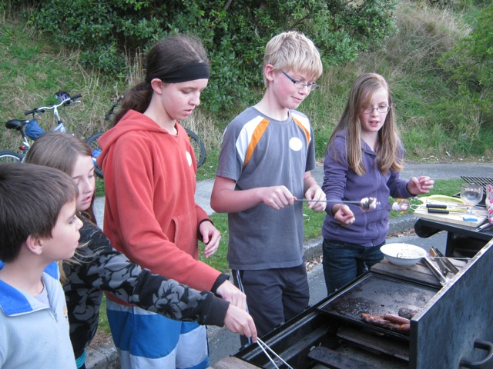

*“Everyone who came enjoyed making contacts with new, and not-so-new, neighbours and seemed to want to do similar events again, hopefully including more who couldn’t come.”*

*“It was very worthwhile and people were very appreciative of an opportunity to meet neighbours. Some of us have met together on previous occasions, but the neighbourhood weekend concept gave us a natural opportunity to invite other people who live nearby as well.”*

*• “The success of the evening was highlighted by several positive comments. We are all keen to keep the neighbourly spirit alive and we heard repeatedly “Let’s do this again!” Sincere thanks goes to the* ***Tawa Community Board*** *who took on the leadership of the Neighbours’ Day initiative. Those of us who organised our street barbecues appreciated the initial public meeting, the informative emails, street notices and resources, etc. It was a great effort that the community board and team made in helping us bring our neighbourhoods and Tawa community closer together.”*

*“We spoke about the reason behind Neighbours’ Day and also about Neighbourhood Support. There’s a great sense of community in our area and it seemed that everyone fitted in very well, really appreciated the opportunity of getting together.”*

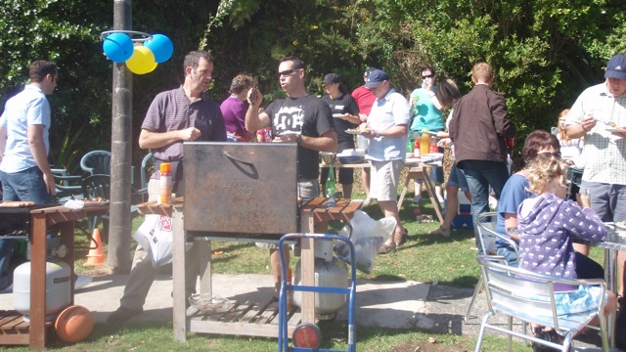

*• “It was a great evening spent chatting to both familiar and unfamiliar neighbours. I now know all the names of the neighbours that live in the upper street section. We would be keen to make it an annual event. I now feel more prepared if we were put in an earthquake situation. 20 households in total were invited and 43 people took part.”*

*“Everyone considered the evening to be a success and I have undertaken to arrange another evening later on, perhaps a mid-winter progressive dinner or “Guess who’s coming to dinner”.”*

*“We got to meet new people to the street and enjoyed memories of past street BBQs and gokarts!”*

*“Our barbecue went really well. Lots of neighbours had never met each other. There was a good connection between older residents and those who had moved in more recently.”*

*“Some who have been living around here for decades met for the first time on a friendly basis and had a chat about what Tawa was like years ago.”*

*“We didn't realise we had so many lovely children in the street. Caught up on street gossip, ate good food and promised to all get together again soon. Thoroughly enjoyable.”*

*“Everyone agreed it was a great idea – let’s do it again. Our age range was 3 years old through to 93 years old.”*

*• “Everyone got to meet others they had never met before and having nametags with first names and house numbers definitely helped to sort out who lives where! We also circulated a list that everyone filled in with their names, house numbers and phone numbers.”*

*“About 30 people ranging from a one year old child through to 80 years old. Somebody asked “Why haven’t we done this for years? It’s wonderful!””*

*“Some people knew each other well, but getting together was beneficial for those of us who leave the neighbourhood each day to go to work.”*

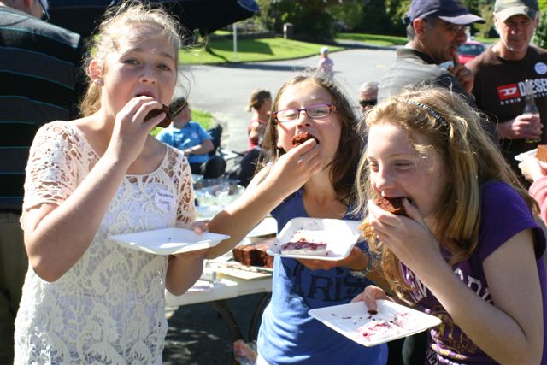

*“It was a very pleasant occasion with attendances ranging from the longest residents in the street (over 40 years) to one not quite born yet but due any moment. For most of us it was the first time we had got to know more than our immediate neighbours and discover what we had been missing.”*

*“There was a good cross mix of ages, and people mixed and mingled well. The event gave us the opportunity of getting to know our neighbours better and meeting some for the first time.”*

*“Many of the residents of the street who had not met, greeted their street counterparts with the question “How long have you been in the street?” Replies ranges from 35 years to just a few months.”*

*“Everyone said how much they appreciated the opportunity to meet the neighbours and asked that it happen again.”*

*“I met one neighbour I hadn’t met before who’s been here 60 years!”*

*• “My goal is to create a warm friendly street where we can help each other out from time to time and look out for our neighbours’ properties if someone is away. We have benefited greatly. An example of this is when we had a truckload of soil delivered on our driveway and two neighbours just turned up after work to help wheelbarrow it around to the back. The load disappeared before my eyes. I was so grateful and beyond words. We are blessed with our neighbours. Relationships are important. We all need each other. Let’s not wait for a disaster to discover that truth.”*

*• “We had lovely food, good laughs and lots of stories were told. The younger kids had a wonderful time with water bombs after lunch and not a dry child was to be found! A very easy to run event, with many benefits for the whole street. Plans are underway to do it again. Thanks to* ***Tawa Community Board*** *for supporting this initiative.”*

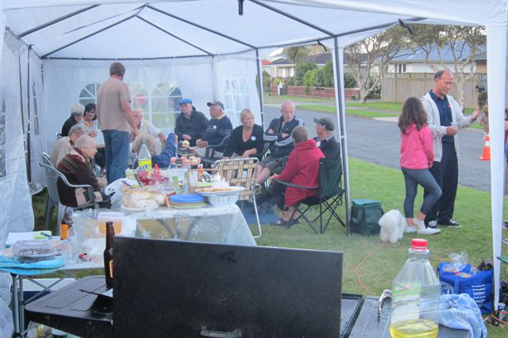

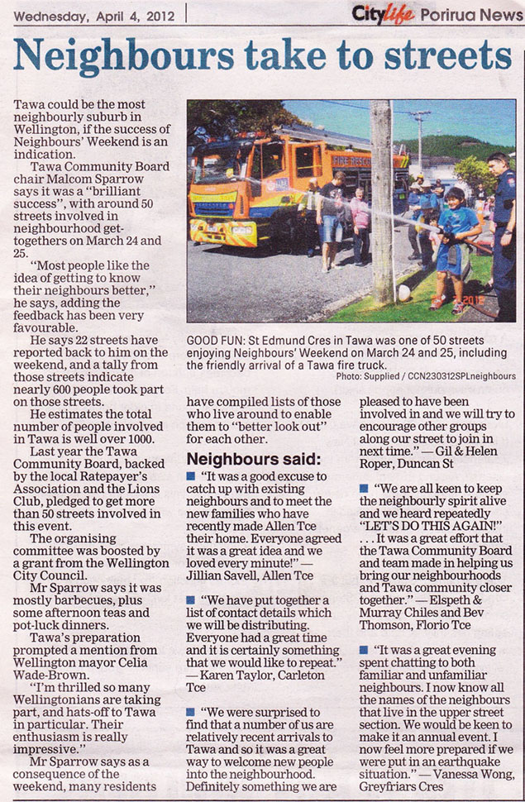

**ONGOING BENEFITS**

As a result of Neighbours’ Weekend in Tawa, a number of streets have now compiled lists of those who live around to enable them to “better look out” for each other. Others have taken it further and actively discussed emergency preparedness planning. As one of the comments above states: *“Relationships are important. We all need each other. Let’s not wait for a disaster to discover that truth.”*

Tawa Community Board is the only urban community board in Wellington City, population approximately 200,000. It is interesting to note that around two-thirds of Neighbours’ Day street gatherings in Wellington took place in Tawa alone – the difference that a community board can make!

More community boards around New Zealand could get actively involved in promoting Neighbours’ Day events in their communities. Climb on board what is a nationwide initiative! It’s well worthwhile.

Having said that, we struggled to get as much advance media coverage as we would have liked and are endeavouring to up the ante in that regard this time around. Local councils also need to promote the concept more than they already do.

Back on the local scene, we received the following just this month (February 2013) in response to our planning towards Neighbours’ Weekend in Tawa in March 2013:

*“We met up again last month at another neighbour’s place just for fun, and we have planned our next barbeque to be an “Emergency Planning Meeting” – date yet to be determined. In the event of an emergency we will check up on each other, making sure that we all have the necessities and sharing resources if needed (i.e. generator, cellphone charger, toilet, etc).”*

Following the success of last year’s Neighbours’ Weekend in Tawa, the Tawa Community Board is working towards seeing a similar number of Neighbours’ Weekend street gatherings taking place in the suburb in March 2013. We recently held a community meeting to provide “Tips for a Barbecue in your Street” and in response to that have received the following from one enthusiastic new organiser:

*“I’ve spoken to most of the neighbours in the top end of Turriff Crescent and had an excellent response to the idea of a get-together …”*

At this stage (late February) we already have 21 streets confirmed for holding a barbecue or similar on or near Neighbours’ Weekend in Tawa in 2013.