A Proposal for a

Porirua Stream Walkway Route

Willowbank to Porirua

Concepts for discussion at a Community Meeting

Sponsored by

Tawa Community Board
Friends of Tawa Bush Reserves

PLEASE DO NOT RE-PUBLISH ANY OF THE MAPS BELOW WITHOUT PERMISSION

This document provides some maps which give an initial route proposal. It has been formulated in sufficient detail to provide a clear view of the concept and of the ways in which it might provide a valuable amenity for many citizens. However it is merely a draft to help provide a basis for discussion. If at the Community Meeting there is a sufficient level of support for the concept, steps can be taken to set up a procedure for developing a detailed plan and for taking the concept further.

Map 1

Takapu Road to Tawa Station

Willowbank to Tawa St

Follows east of rail. Requires negotiation with OnTrack for access along a small section north of the Willowbank reserve.
The remainder is in Taylor Park.

Tawa St to Tawa Station

There are a range of alternatives.

A route west of the rail and along the eastern bank of the stream would require a bridge and some agreement from landowners who do not use the eastern side of the stream banks in their properties. Alternatively it may be possible to improve the access to Redwood rail station and construct a route north from there on the eastern bank of the stream.

The route in red on the east of the rail is in reserve land.
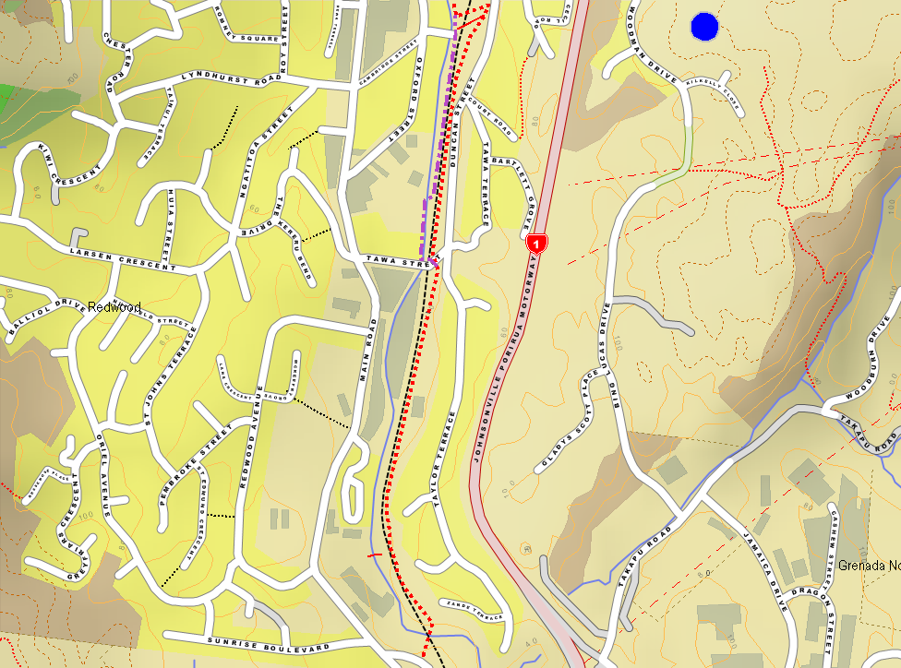
Map 2

Tawa Station to Linden Ave

The draft route follows reserve areas where possible.

In several locations the draft route would only be feasible with either some land acquisition or agreement from landowners.
There are several alternatives in the McClellan St area.
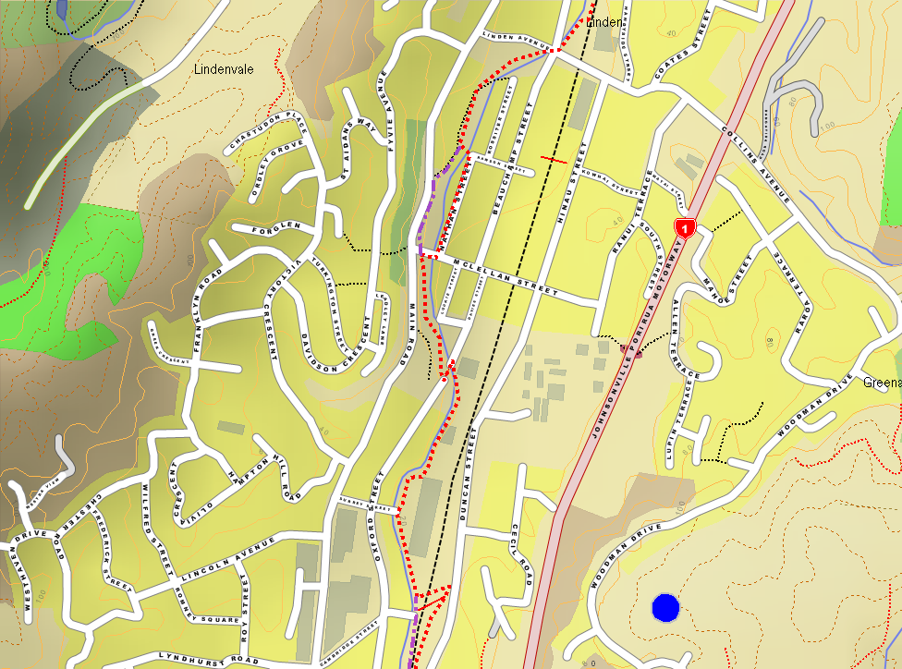
Map 3

Collins Ave and North

In the area north of Collins Ave the route is particularly tentative and would require detailed consideration in conjunction with proposed flood protection works along the stream. Alternatives adjacent to the rail route, or using Findlay Street might be initial routes during development.

There are options for the northern end of the route. It could join to the Porirua City tracks. It would be attractive to have routes from Kenepuru on both sides of the stream – but that is within Porirua City and their responsibility.

It would clearly be desirable to construct some additional access points through the industrial area in the northern end of the city.

Note access is provided across the rail at the Kenepuru Station.
